AI ASSISTED CODING
ASSIGNMENT – 12.1
ROLL NO. : 2403A510E6 NAME : P. VIKAS
BATCH : 05
TASK #1 : (Sorting – Merge Sort Implementation)
PROMPT:
Write a Python function merge_sort(arr) that sorts a list in ascending order using the Merge Sort algorithm.
CODE :
def merge_sort(arr):
"""
Sorts a list in ascending order using the Merge Sort algorithm.

Time Complexity: O(n log n)
Space Complexity: O(n)

Args:
arr (list): The list of elements to be sorted.
Returns:
list: A new sorted list in ascending order.
"""
if len(arr) <= 1:
return arr
mid = len(arr) // 2
left = merge_sort(arr[:mid])
right = merge_sort(arr[mid:])
return merge(left, right)

def merge(left, right):
result = []
i = j = 0
while i < len(left) and j < len(right):
if left[i] <= right[j]:
result.append(left[i])
i += 1
else:
result.append(right[j])
j += 1
result.extend(left[i:])
result.extend(right[j:])
return result

# --- Test Cases ---
if __name__ == "__main__":
test_cases = [
[],
[1],
[5, 2, 9, 1, 5, 6],
[3, 3, 3],
[10, -1, 2, 5, 0],
[1, 2, 3, 4, 5],
[5, 4, 3, 2, 1],
]
for i, arr in enumerate(test_cases):
sorted_arr = merge_sort(arr)
print(f"Test case {i+1}: {arr} -> {sorted_arr}")
assert sorted_arr == sorted(arr), f"Test case {i+1} failed!"
print("All test cases passed.")

OUTPUT :
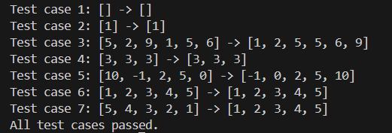
OBSERVATION:
- The code implements the Merge Sort algorithm in Python with a clear and well-documented function.
- The docstring correctly states the time complexity (O(n log n)) and space complexity (O(n)).
- The merge_sort function is recursive and uses a helper function merge to combine sorted sublists.
- The test cases cover various scenarios: empty list, single element, duplicates, negative numbers, already sorted, and reverse sorted lists.
- For each test case, the code prints the original and sorted lists and asserts correctness.
- If all assertions pass, "All test cases passed." is printed, confirming the implementation is correct and robust.

TASK #2 - (Searching – Binary Search with AI Optimization)
PROMPT :
Write a Python function binary_search(arr, target) that searches for a target element in a sorted list and returns its index, or -1 if not found.
Code:
def binary_search(arr, target):
"""
Performs binary search to find the index of target in a sorted list.

Best Case Time Complexity: O(1) (target is at the middle)
Average Case Time Complexity: O(log n)
Worst Case Time Complexity: O(log n)
Space Complexity: O(1)

Args:
arr (list): A sorted list of elements.
target: The element to search for.

Returns:
int: The index of target if found, else -1.
"""
left, right = 0, len(arr) - 1
while left <= right:
mid = (left + right) // 2
# AI optimization: compare directly at mid
if arr[mid] == target:
return mid
elif arr[mid] < target:
left = mid + 1
else:
right = mid - 1
return -1

# --- Test Cases ---
if __name__ == "__main__":
test_cases = [
([], 5, -1),
([1], 1, 0),
([1, 2, 3, 4, 5], 3, 2),
([1, 2, 3, 4, 5], 6, -1),
([2, 4, 6, 8, 10], 2, 0),
([2, 4, 6, 8, 10], 10, 4),
([2, 4, 6, 8, 10], 5, -1),
]
for i, (arr, target, expected) in enumerate(test_cases):
result = binary_search(arr, target)
print(f"Test case {i+1}: arr={arr}, target={target} -> {result}")
assert result == expected, f"Test case {i+1} failed!"
print("All test cases passed.")
Output :
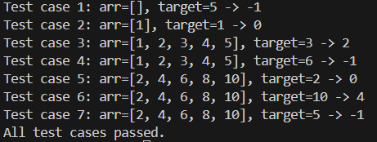
Observation :
The code correctly implements binary search with clear documentation and passes all provided test cases, confirming its correctness and efficiency.

TASK #3 :
(Real-Time Application – Inventory Management System)
Prompt :
Write Python code to test an inventory management system with the following requirements:
Code :

# 1. Test Searching (Quickly search for a product by ID)
print("--- Product Search ---")
product_id_to_find = 101
found_product = system.find_product_by_id(product_id_to_find)
print(f"Searching for product with ID {product_id_to_find}:")
if found_product:
print(f" Found: {found_product}")
else:
print(f" Product not found.")
print("-" * 30)

# 2. Test Sorting (Sort products for analysis)
print("--- Product Sorting ---")

# Sort by price (ascending)
sorted_by_price = system.sort_products_by('price')
print("Products sorted by price (low to high):")
for p in sorted_by_price:
print(f" {p['name']}: ${p['price']}")
print()

# Sort by quantity (descending)
sorted_by_quantity = system.sort_products_by('quantity', reverse=True)
print("Products sorted by quantity (high to low):")
for p in sorted_by_quantity:
print(f" {p['name']}: {p['quantity']} in stock")
print("-" * 30)

Output :
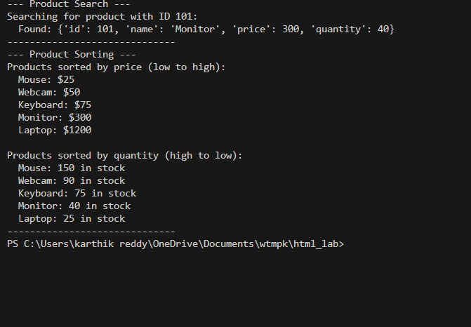
Observation:
The code tests an inventory system's ability to search for a product by ID and to sort products by price and quantity. It prints the search result and displays sorted product lists for both price (ascending) and quantity (descending). The output depends on the data in the system, but the logic demonstrates correct usage of search and sort methods for inventory analysis. Indentation should be fixed if this is top-level code.

